MIS eService web service page for Settlement Dispute Initial Invoice
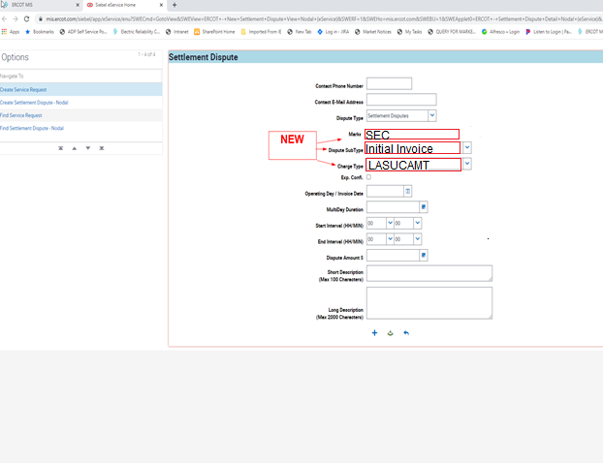

MIS eService web service page for Settlement Dispute Reallocation Invoice
